**Barakha Enterprise Ltd.**

* Home
* About Us
* Products list
* Contact
* Career
* Why Choose us
* Inquire now
* About us:

**Barakha Enterprise Ltd.** was established in March 2023, our mission is to serve customers worldwide by providing top quality minerals, metals, and agricultural products at competitive prices. Reputation, transparency and responsibility before, during and after transactions with customers are our core values. Commitment to ethical business standards is the basis for Barakha Enterprise Ltd. to become one of the businesses with sustainable development in the industry. With presence in 6 countries through our partners and affiliates, we today have a demonstrated global reach and scale.

Our team of experienced trading professionals help clients move physical commodities across the world as per their requirements. We source from the lands of plentiful and bring/distribute it to where there is a demand. We have built strong connections across the globe due to our excellent understanding of market dynamics and highly efficient logistic solutions that we provide to our clients.

* **Products list:**

1. Metal & Minerals
2. Agricultural Products

* Metal & Minerals: a) Copper Cathode b) Thermal Coal
* Agricultural Products:

|  |
| --- |
| 1.       Sunflower oil |
| 2.       Soya Bean Oil |
| 3.       Cardamom |
| 4.       Yellow Maize |
| 5.       White Maize |
| 6.       Green Mung Beans |
| 7.       Red Kidney Bean |
| 8.       White Kidney Bean |
| 9.       Kabuli Chickpeas |
| 10.    Red Lentils |
| 11.    Coffee Beans |
| 12. Raw Cashew nuts |
| 13. Processed Cashew nuts |
| 14.    Peanuts |
| 15.    Pistachio Nuts |
| 16.    Almond Nuts |
| 17.    Cloves |
| 18.    Black Pepper |
| 19.  White Pepper |
| 20.  Soya bean |
| 21. Sesame Seeds |
| 22. Dry Chili |
| 23. Dates |

**@Contact: Our Global offices:**

|  |  |
| --- | --- |
| **Singapore office:**  138 JURONG GATEWAY ROAD, Singapore 600134.  Cell: +65-91517201  Email: head-office@barakha-enterprise.com | **Bangladesh Office:**  House-1, Road-5, Block-G/1  Mirpur-2, Dhaka, Bangladesh  Cell: +880-1982248470  Email: BD-office@barakha-enterprise.com |
| **Vietnam Office:**  No 21 Street 15, Tan Hung Ward,  District 7, HCM City, Vietnam  Cell: +84-796765222  Email: HCM@ barakha-enterprise.com | **Tanzania Office:**  NHC House, Samora Avenue,  Dar es Salaam, Tanzania  Cell: +255-759178179  Email: Tanzania@barakha-enterprise.com |
| **Dubai Office:**  House-122, Salah Uddin Street,  Al Muteena, Deira, Dubai, UAE  Cell: +971-508267926  Email: UAE@ barakha-enterprise.com | **Indonesia Office:**  Bakrie Tower  Jl. H. R. Rasuna Said, Karet Kuningan, Setiabudi  DKI Jakarta 12940, Indonesia  Cell: +62-82142841381  Email: Indonesia@barakha-enterprise.com |

* **Why Choose us**

- Reputation: Customer trust is the guiding principle for all activities

- Diversity: We offer a variety of top quality products

- Responsibility: Responsibility to products and customers always comes first.

- Commitment:

* **Inquire now**

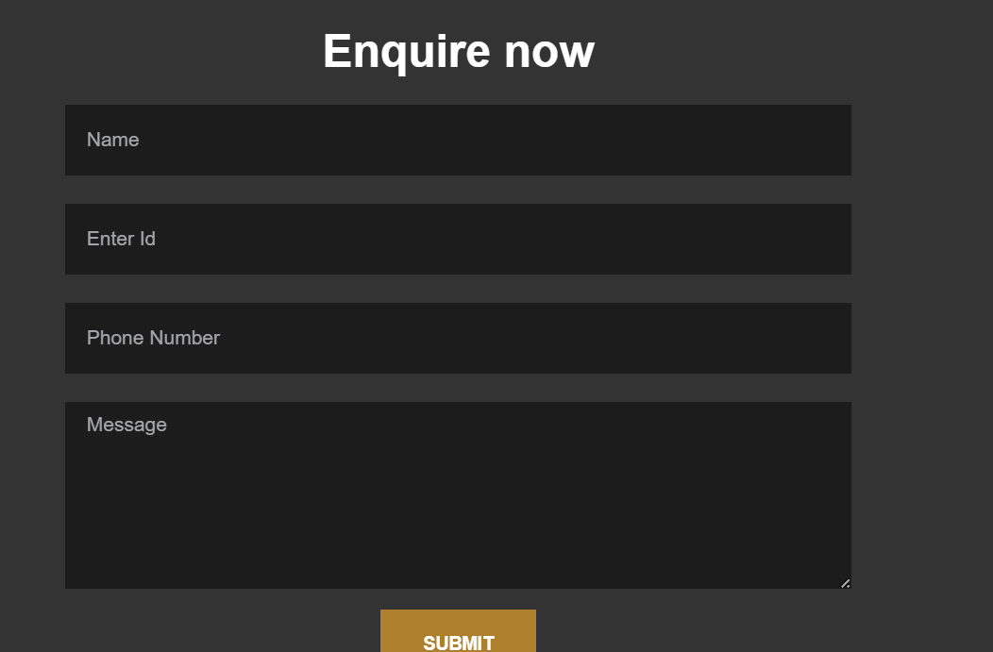

Ref website:

<https://k-agriculture.com/spring-star-anise/>

<https://vinagreenjsc.com/en/>

https://www.myancashew.com/

<https://cptcorp.vn/product-categories/raw-cashew-kernels-2/>

<https://kimmyfarm.com/en/vietnam-cashew-nuts>

<https://www.spicessupplierid.com/>